IHE Devices Work Item Proposal (Short)

# Proposed Work Item: Medical Device Interoperability Reference Architecture (MDIRA)

Proposal Editor: Todd Cooper

Work item Editor: JHU/APL Team, incl. Todd Cooper

Date: 2020.09.25

Version: 1.3

Domain: Devices

# The Problem

The Johns Hopkins University / Applied Physics Lab (JHU/APL) has been conducting applied research ***for technical architectures to support autonomous medical systems for prolonged care in austere environments and hospitals of the future***. This resulted in the specification of a Medical Device Interoperability Reference Architecture (MDIRA) that utilizes the Integrated Clinical Environment (ICE) framework standardized by ASTM and now AAMI 2700 series. In building a MDIRA Reference Implementation (RI), the MDIRA team utilized the ISO/IEEE 11073 Service-oriented Device Connectivity (SDC) standards, creating a service-oriented ICE prototype demonstration implementation of the MDIRA specification.

The specific challenges and opportunities related to Device Point-of-care Interoperability (DPI) is well established … for decades. The specific APL MDIRA program value proposition is well illustrated in the video referenced in the following section. Once the reference implementation is completed, though, demonstrating the feasibility and value of the MDIRA, the ***next problem*** is how to advance toward establishing an ecosystem of conformant, interoperable acute care medical device products.

# Key Use Case

The JHU/APL MDIRA project use cases are well documented on the [project’s public web site](https://secwww.jhuapl.edu/mdira/), as well as illustrated in a [video (YouTube)](https://youtu.be/EdWZgn8EoQI). Analysis of this use case was also included in the [IHE SDPi White Paper](https://www.ihe.net/uploadedFiles/Documents/PCD/IHE_PCD_WP_SDPi_Rev1-1_Pub_2019-11-01.pdf), as well as inclusion of the ICE-related use cases in the [SDPi White Paper – Use Case Compendium document](https://www.ihe.net/uploadedFiles/Documents/PCD/IHE_PCD_WP_SDPi_UseCases_Rev1-1_Pub_2019-11-01.pdf). Additionally, as part of the Gemini MDI using SDPi+FHIR project, in anticipation of this profile proposal a [confluence page with additional reference materials was created for the MDIRA Narrative](https://confluence.hl7.org/x/GA7xB).

Specific use cases focus on ***trauma and critical care in austere environments, including military conflict and natural disaster contexts.***

# Standards & Systems

The Gemini SDPi+FHIR program’s [Hanging Gardens framework](https://confluence.hl7.org/pages/viewpage.action?pageId=82913506#HangingGardensFramework-HangingGardensModel"HangingGardens"SESMDIModel-GeminiSDPi+FHIRStandardsCoordinationModel) establishes the context for the MDIRA profile being proposed. Specifically, the IHE Devices MDIRA profile would be part of the “*SDPi+FHIR Profiles / IGs*” layer, and would leverage the other standards identified in the model, including:

1. [JHU/APL MDIRA Specification](https://secwww.jhuapl.edu/mdira/) (ver 1.1)
2. [IHE SDPi Profiles](https://confluence.hl7.org/pages/viewpage.action?pageId=82906654#Specifications:SDPiIHEProfiles-SDPi-FrameworkModel) (and profiled ISO/IEEE 11073 SDC standards)
3. AAMI 2700-1 ICE standard & 2700-2 Forensics Data Logger (draft) standard

Note: Items (1) and (3) are both included in the “*Ref. Arch. / Frameworks*” layer.

# Discussion

As the JHU/APL MDIRA work advances to potential product implementations, the IHE Devices Technical Framework, especially the SDPi profiles, and the IHE processes around product-focused profiling specification development, prototyping, testing and ultimately conformity assessment, provides the perfect avenue for creating a community of interest for advancing MDIRA-based profile specifications and product implementations.

The following graphic provides an example of a MDIRA reference implementation that might be supported by this profile proposal:

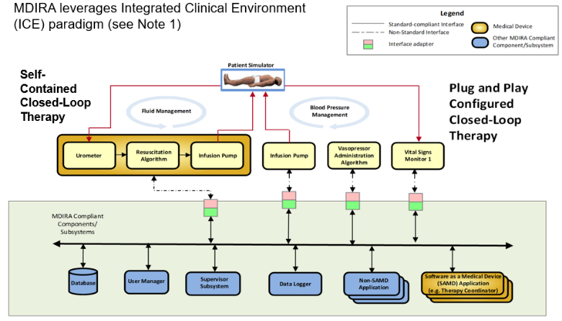

For example, actors and transactions from the SDPi profile would be leveraged for SDC-based MDI, and new actors and transactions defined, such as “Supervisor”, “Data Logger” and “Therapy Coordinator” (SAMD). It is recognized that the topics contained in the above illustration are significant, both in terms of breadth and technical challenge. The focus and scope of this profile, as well as what aspects will be deferred to proposed future profiles, will be established during the development of the MDIRA Detailed Profile Proposal.